SYDNEY WESTERN CITY PLANNING PANEL

Panel Number: | PPSSWC-72
Application Number: | 2020/202/1
Local Government Area: | Camden.
Development: | Subdivision of land to create four superlots, stratum subdivision of superlot No. 3 to create 5 stratum lots, construction of 340 car parking spaces within basements, at grade and under croft car parking spaces, construction of 12 buildings to create a mixed use precinct consisting of a grocer, an 80 place childcare centre, aquatic centre and gymnasium, cinema, medical building, commercial suites and individual tenancies for food and beverage outlets and other retail business’, shop top housing comprising 63 apartments in three separate buildings with a mix of 27 x one bedroom, 34 x two bedroom and 2 x three bedroom dwellings, construction of a public road and pedestrian dominated shared way and public domain works, business identification signage, landscaping and associated site works.
Capital Investment Value: | $63.8 million.
Site Address(es): | 1-9 Providence Drive, Gledswood Hills
Applicant: | SJB Planning
Owner(s): | SH Camden Valley Pty Ltd
Date of Lodgement: | 1 April 2020.
Number of Submissions: | Seven (7)
Number of Unique Objections: | Seven (7)
Classification: | Regionally significant development.
Recommendation: | Approve with conditions.
Regional Development Criteria (Schedule 7 of State Environmental Planning Policy (State and Regional Development) 2011): | General development capital investment value >$30 million.
List of All Relevant Section 4.15(1)(a) Matters: | - State Environmental Planning Policy (State and Regional Development) 2011  - State Environmental Planning Policy (Sydney Region Growth Centres) 2006  - State Environmental Planning Policy (Infrastructure) 2007.  - State Environmental Planning Policy (Educational Establishments and Child Care Facilities) 2017  - State Environmental Planning Policy No 55 - Remediation of Land.  - State Environmental Planning Policy No 64 - Advertising and Signage  - State Environmental Planning Policy No. 65 – Design Quality of Residential Apartment Development  - State Environmental Planning Policy (Building Sustainability Index: BASIX) 2004  - Sydney Regional Environmental Plan No 20 - Hawkesbury-Nepean River  - Camden Development Control Plan 2019  - Turner Road Precinct Development Control Plan 2019  - Apartment Design Guide
List all Documents Submitted with this Report for the Panel’s Consideration: | - Assessment report.  - State Environmental Planning Policy (Sydney Region Growth Centres) 2006 assessment table.  - State Environmental Planning Policy (Educational Establishments and Child Care Facilities) 2017 assessment table.  - Apartment Design Guide assessment table.  - Turner Road Precinct Development Control Plan 2019 assessment table.  - Child Care Planning Guideline Assessment Table.  - Recommended conditions.  - Proposed plans.  - Submissions.
Development Standard Contravention Request(s): | - Nil
Summary of Key Submission Issues: | - Increased traffic and danger to pedestrians and school children  - Height of development and visual impact on the streetscape  - Aesthetics of the area  - Parking  - Attraction of unwanted people to the area, crime and security  - No need for additional units/apartments, proposed businesses and medical centres and childcare facilities within Gledswood Hills  - Garbage/litter  - Undesirable precedent for future development  - Poor quality build  - Devalue property prices
Report Prepared By: | Adam Sampson, Executive Planner
Report Date: | 26 March 2021

Summary of Section 4.15 Matters

Yes
Have all recommendations in relation to relevant Section 4.15 matters been summarised in the Executive Summary of the assessment report?

Legislative Clauses Requiring Consent Authority Satisfaction

Yes
Have relevant clauses in all applicable environmental planning instruments where the consent authority must be satisfied about a particular matter been listed and relevant recommendations summarised in the Executive Summary of the assessment report?

Development Standard Contraventions

 | Yes | N/A
If a written request for a contravention to a development standard has been received, has it been attached to the assessment report?

Special Infrastructure Contributions

 | Yes | No
Does the application require Special Infrastructure Contributions?

Conditions

Yes
Have draft conditions been provided to the applicant for comment?

PURPOSE OF REPORT

The purpose of this report is to seek the Sydney Western City Planning Panel’s (the Panel’s) determination of a development application (DA) for a mixed-use development at 1 - 9 Providence Drive, Gledswood Hills.

The Panel is the consent authority for this DA as the capital investment value (CIV) of the development is $63.8 million. This exceeds the CIV threshold of $30 million for Council to determine the DA pursuant to Schedule 7 of State Environmental Planning Policy (State and Regional Development) 2011.

SUMMARY OF RECOMMENDATION

That the Panel determine DA/2020/202/1 for a mixed-use development pursuant to Section 4.16 of the Environmental Planning and Assessment Act, 1979 by granting consent subject to the conditions attached to this report.

EXECUTIVE SUMMARY

Council is in receipt of a DA for a mixed - use development at 1 - 9 Providence Drive, Gledswood Hills.

The DA has been assessed against the Environmental Planning and Assessment Act 1979, the Environmental Planning and Assessment Regulation 2000, relevant environmental planning instruments, development control plans and policies.

A summary of the assessment of all relevant environmental planning instruments is provided below with a detailed assessment provided later in the report.

State Environmental Planning Policy (State and Regional Development) 2011. | The Panel is the consent authority for this DA as the development has a CIV of $63.8 million which exceeds the CIV threshold of $30 million for Council to determine the DA.
State Environmental Planning Policy (Sydney Region Growth Centres) 2006 (Growth SEPP). | The development is permitted with consent in the applicable R1 General Residential and B4 Mixed Use zones, is consistent with the zones’ objectives and acceptable in terms of the Growth SEPP’s other matters for consideration.
State Environmental Planning Policy (Infrastructure) 2007 (ISEPP). | The DA was referred to Transport for NSW and Endeavour Energy for comment pursuant to the ISEPP and the comments received have been considered.
State Environmental Planning Policy (Educational Establishments and Child Care Facilities) 2017. | The proposed development is consistent with the matters for consideration prescribed by the Child Care Planning Guideline and satisfies each of the non-discretionary development standards pursuant to Clause 25 of the SEPP.
State Environmental Planning Policy No 55 - Remediation of Land. | Several development consents have been issued for remediation works across the development site, with a Site Audit Statement issued for the bulk of the Entertainment Precinct development site. An unexpected find discovered on the site following demolition of the former motel, is yet to be remediated and validated. Subject to remediation works being completed and validated, the site is considered suitable for future commercial and residential use.
State Environmental Planning Policy No 64 - Advertising and Signage (SEPP 64) | Council staff are satisfied that the signage is consistent with SEPP 64’s objectives in that it is compatible with the desired amenity and visual character of the area, will provide effective communication by displaying the development’s name and will be of a high quality design and finish. Council staff have also considered SEPP 64’s Schedule 1 assessment criteria and are satisfied that the signage is consistent with it.
State Environmental Planning Policy No. 65 – Design Quality of Residential Apartment Development | The development is largely consistent with the Design Quality Principles and the Apartment Design Guide.
State Environmental Planning Policy (Building Sustainability Index: BASIX) 2004 | The applicant has submitted valid BASIX Certificates in support of the DA that demonstrates that water, thermal comfort and energy requirements have been achieved.
Sydney Regional Environmental Plan No 20 - Hawkesbury-Nepean River (SREP 20). | The development is consistent with the aim of SREP 20 (to protect the environment of the Hawkesbury-Nepean River system) and all of its planning controls.

The DA was publicly exhibited for a period of 27 days in accordance with Camden Development Control Plan 2019. The exhibition period was from 29 April to 26 May 2020. Seven submissions were received raising the following issues:

- Increased traffic and danger to pedestrians and school children
- Height of development and visual impact on the streetscape
- Aesthetics of the area
- Parking
- Attraction of unwanted people to the area, crime and security
- No need for additional units/apartments, proposed businesses and medical centres and childcare facilities within Gledswood Hills
- Garbage/litter
- Undesirable precedent for future development
- Poor quality build
- Devalue property prices

The applicant proposes variations to the location of the local access road through the Entertainment Precinct, proposing to relocate the east / west road further to the south; the width of the local street, including verge and carriageway width (east / west road - ‘The Green Way’); and to the width of the principle view corridor through the Entertainment Precinct contained within Turner Road Precinct Development Control Plan 2019. These variations are assessed in detail in this report and are supported by Council staff.

Based on the assessment, it is recommended that the DA be approved subject to the conditions attached to this report.

KEY PLANNING CONTROL VARIATIONS

Control | Proposed | Variation
Principle View corridor – 20m | 14m (at the narrowest point) | 6m (30%).

AERIAL PHOTO

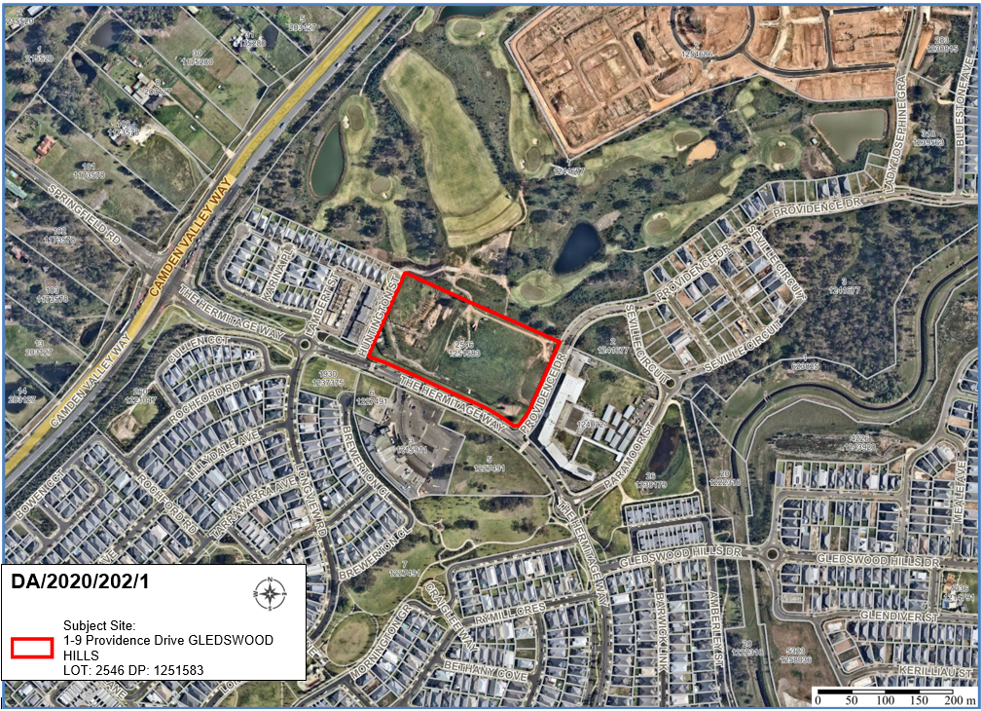

THE SITE

The development site is commonly known as 1–9 Providence Drive, Gledswood Hills and is legally described as Lot 2546 DP 1251583.

The overall Entertainment Precinct as per the Turner Road Precinct Development Control Plan 2007 will ultimately exist over four lots (1-9 Providence Drive, Gledswood Hills Lot 2546 DP 1251583; D & E The Hermitage Way, Gledswood Hills Lot 5 DP 1227491; Lot 6 DP 1227491; and 91 The Hermitage Way, Gledswood Hills Lot 3 DP 121599).

The development site is rectangular in shape and has a frontage of approximately 250m to The Hermitage Way, 133m to Providence Drive and 132m to Huntington Street, with an area of 3.363 hectares. The development site is currently vacant.

To the north of the site is the former El Caballo Blanco tourist park, which is currently being redeveloped for a residential subdivision surrounded by a golf course.

To the east adjacent to Providence Drive is Gledswood Hills Primary School.

To the west adjacent to Lambert Street is a series of residential dwellings.

To the south opposite The Hermitage Way is Wests Leagues Country Club. The site is located in the Turner Road Precinct of the South West Growth Area.

ZONING PLAN

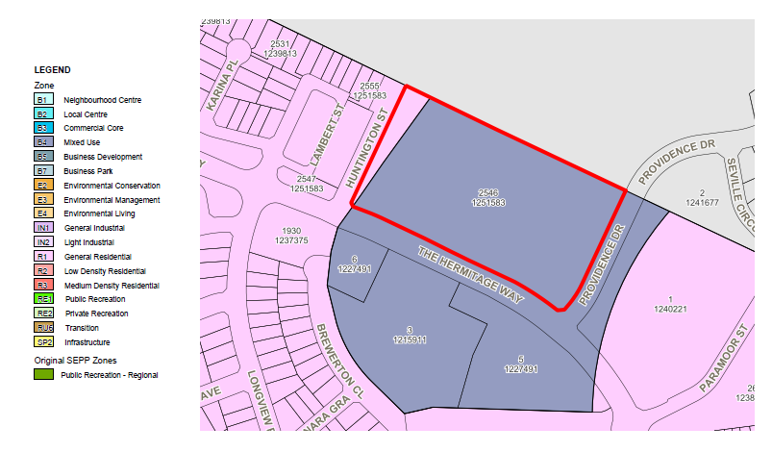

AREA MASTER PLAN

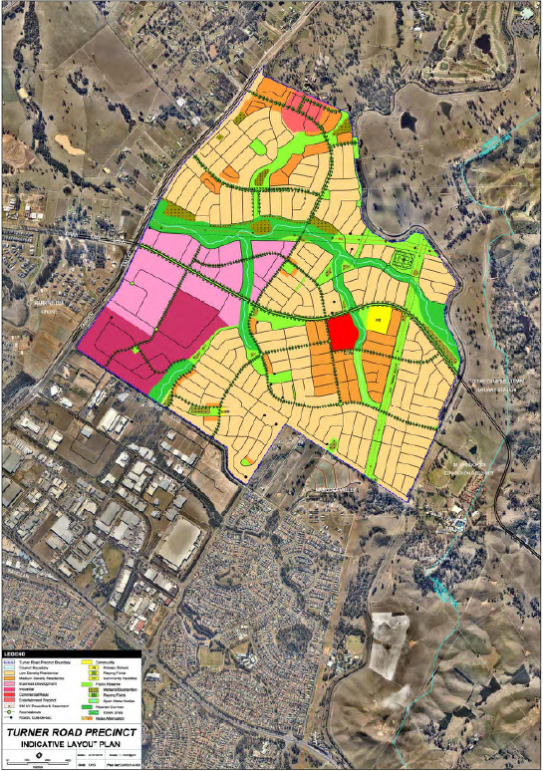
Entertainment Precinct

HISTORY

The relevant development history of the site is summarised in the following table:

Date | Development
28th January 2014 | Development consent for the remediation of land was granted subject to DA/2013/854/1.
16th June 2016 | Development consent for the demolition of motel buildings, tennis court and swimming pool was granted subject to DA/2016/407/1.
20th December 2016 | Development consent for bulk earthworks and associated site works was granted subject to DA/2016/1180/1.
17th November 2017 | Development consent subject to DA/2016/1180/2 was modified via Section 96(2) of the Act to include additional remediation following an unexpected find as part of approved bulk earthworks.
12th March 2020 | Development consent for remediation of unexpected finds and bulk earthworks was granted subject to DA/2019/215/1.

THE PROPOSAL

DA/2020/202/1 seeks approval for the construction and use of a mixed-use development.

Specifically, the development involves:

- Subdivision of land to create four superlots and stratum subdivision of superlot No. 3 to create 5 stratum lots;

- Construction of 340 car parking spaces within basements, at grade and under croft car parking spaces (114 residential and 126 non-residential spaces);

- construction of a mixed use commercial development comprising of 12 buildings to create a mixed-use precinct consisting of a grocer, an 80 place childcare centre, aquatic centre and gymnasium, cinema, medical building, commercial suites and individual tenancies for food and beverage outlets and other retail business’ and shop top housing ranging in height from 1 to 5 storeys;

- shop top housing comprising 63 apartments in three separate buildings with a mix of 27 x one bedroom, 34 x two bedroom and 2 x three bedroom dwellings;

- construction of a public road (dedicated to Council as future public road) and a pedestrian dominated shared way (retained in private ownership) and public domain works;

- business identification signage, landscaping and associated site works.

- the development will be constructed of a mix of face brick including recycled face brick, metal, fibre cement and bluestone cladding, concrete off-form finish, exposed steel, vertical timber cladding and timber battens and vertical metal cladding.

- operating hours of:

- Grocer / Supermarket: Monday to Sunday, 7am-9pm
- Childcare centre, Monday to Friday, 7am – 6pm
- Aquatic centre and Gymnasium, Monday to Sunday, 5am – 10pm
- Cinema, Monday to Sunday, 9am – 10pm
- Medical Centre, Monday to Sunday, 7am – 9pm
- Business Premises, Retail Premises and Shop, Monday to Sunday, 8am – 6pm
- Commercial Suites, Monday to Friday, 8am – 6pm, and
- Food and Beverage premises, Monday to Sunday, 7am – 10pm.

Construction of the development will be staged, with the applicant submitting a detailed staging plan of the entire development. The initial stage of the development is proposed to deliver the core public and commercial functions of the precinct and provides the base facilities (such as parking, loading and commercial waste).

The initial development stage will construct Building C1 – Childcare centre; Building C3 – Retail area, gym and the facilities area of the aquatic centre; Building C4 – Ground floor retail and upper level commercial suites; Building C5 – Retail areas; Building C6 – Loading dock and servicing areas for the retail area; Building C7 – Retail area; Building C8 – Retail area; the eastern portion of The Green Way linking the shared way to Providence Drive; the corso space between buildings C4 and C4, including the shared way; the playground area; the pedestrian walkway and stair access between Providence Drive and the Shared Way; and part of the under-croft parking structure below grade to buildings C4, C5, C6 and C7. It is intended that the majority of the bulk earthworks are also completed within the initial development stage, including the bulk excavation for buildings C9 to C12. A temporary car park located on the future site of buildings C9 and C10, accessed from The Hermitage Way, will also be constructed providing parking to the village and specifically for the childcare centre.

Following the delivery of the initial development stage, the subsequent stages will be constructed including Building C11 – Ground floor retail and three levels of residential units, including the plaza space between C11 and the Shared Way; a driveway crossing and a driveway across the site of future Building C12; Building C12 – Medical Centre, including the landscaped space open space between buildings C11 and C12; and Building C2 – Aquatic Centre.

Construction of the on-grade parking located to the west of Building C1, the pedestrian pathway from the on-grade parking area to the childcare centre and the construction of the western portion of The Green Way linking the shared way with Huntington Street.

Construction of Buildings C9 and C10 – Shop Top housing blocks, including removal of the temporary car park fronting The Hermitage Way, bulk earthworks, construction of the access laneway and shared basement parking area of C9 and C10, landscape works, footpath works and a temporary pedestrian connection to the west of Building C9 and finally construction of Building C6 – Cinema.

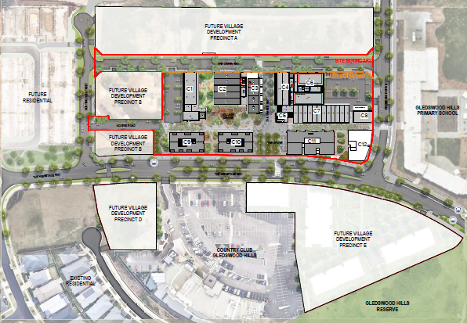
Image 1 – Gledswood Village Master Plan

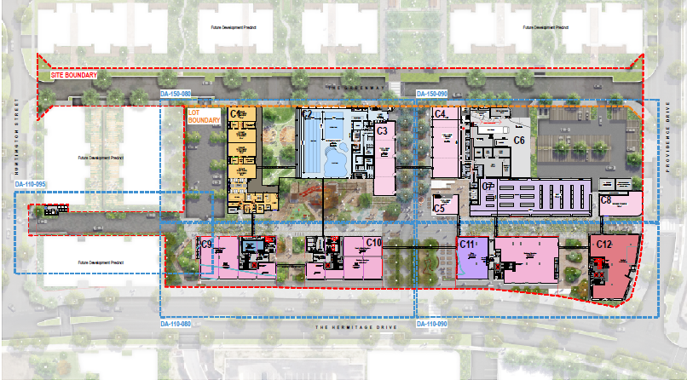
Image 2 – Entertainment Precinct Site Plan

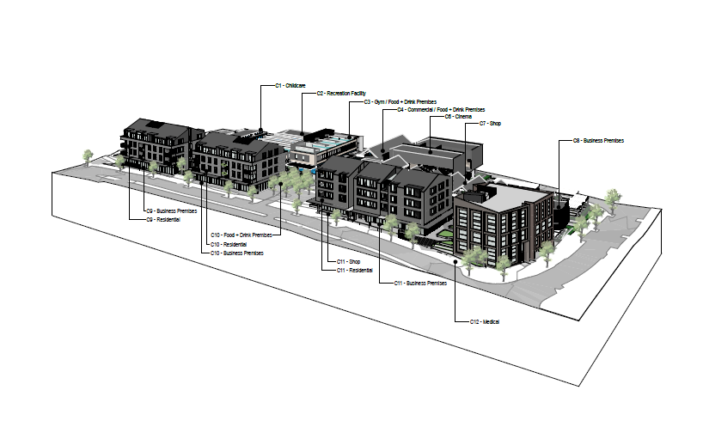
Image 3 – 3D View South East Perspective

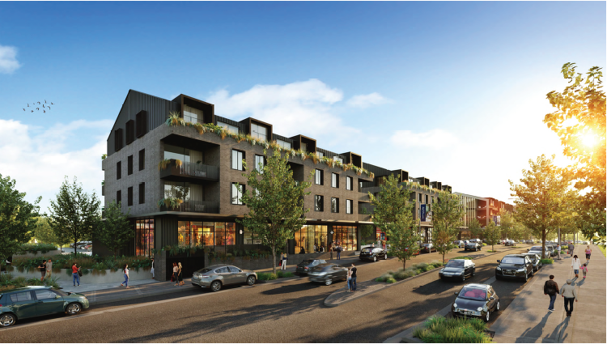
Image 4 – South West Street Perspective

PANEL BRIEFING

Council staff briefed the Panel on the DA on 1 June 2020. The following discussion provides an assessment of how the issues raised by the Panel at the briefing have been addressed:

- The scheme is notable for relying principally on the public domain for the common open space for the development. This is an available approach which may work well for a development of this density and character, but the quality of the public domain and its activation will consequently be more critical.

Council Comment

An allocated and defined area of communal open space is not proposed for the residential development. The location of residential apartments is situated adjacent to a large publicly accessible open space area containing a village square and playground, which will be surrounded by a vibrant entertainment precinct, which will contain a cinema, various food and drink premises, a gymnasium and aquatic centre and shops.

The development has been designed to create a village character, with a large central accessible space that is vibrant and playful. The central open space is highly activated via glazed shopfronts fronting the village centre, and through multiple pedestrian pathways leading to Gledswood Hills Primary School and to the Gledswood Hills Country Club. The central village square is linked to other wide public domain areas within the proposed development, allowing for external dining areas and opportunities for social interaction.

The proposed public domain area is considered to be a positive focal point for the Entertainment Precinct and has been well designed, with good building separation and layout surrounding the central open space area and utilising quality materials and landscaping.

- Ecology should be considered in terms of heat island effects. Roofing and paving materials, and colour palette choices should not exacerbate these problems. The panel would be interested as to whether solar panels could be accommodated.

Council Comment

The applicant has responded to this concern and have undertaken a review of solar absorptance and solar reflective index by an Accredited Green Star Professional. As a result, the applicant has amended 2,283m² of roof area across Precinct C development, changing the colourbond roof colour from Monument to Shale Grey and introducing 510m² of shade structures and integrated planting atop this shade structure on the open on-grade parking area adjacent to Providence Drive and The Green Way to assist in heat island affects.

The applicant’s Green Star consultant advises that the proposed development will deliver the following commitments to reduce heat island impacts:

- 1,793m² of natural landscaping area from the open space area, children’s playground and other landscaping on-site.
- 2,283m² of light-coloured roofing achieving a minimum Solar Reflectivity Index (SRI) of 64.
- Installation of 20m² solar panels.
- 2,174m² of hardstand elements shaded by either vegetation or fixed structures.
- 1,724m² of unshaded hardstand with light coloured pavement achieving an SRI above 34
- 3,120m² of tree canopy.

Based on these commitments, the percentage of low heat island impacts is 75.3%. A contribution above 75% is consistent with the Australian Best Practice Standard (Green Star) for heat island effect reduction. Accordingly, the proposed developments commitments are considered satisfactory in avoiding heat island impacts and are supportable based on the current best practice standards.

Solar panels are proposed on the roofs of shop top housing buildings C9, C10 and C11 in accordance with BASIX Commitments. BASIX prescribes that the photovoltaic system on the roofs of the C9, C10 and C11 buildings are to achieve a minimum rated electrical output of 5.0 peak kW. In addition, and subject to further detailed design at the construction certificate stage, building C6 indicatively nominates two areas capable of supporting solar panel installation.

Whilst the colour scheme and palette choices are distinguishable from other built forms in the immediate locality, they’re high quality everlasting materials which are warranted in identifying the Entertainment Precinct and creating a focal point for residents and their guests to meet and to interact.

- Pedestrian paths (and accessible pedestrian paths) through the site should be considered carefully. For example, a graded level change or ramp for the path between buildings C8 and C12.

Council Comment

The public domain levels development controls set a preferred RL of 132 for the bulk of the Entertainment Precinct, with variation permitted between RL 131 and RL 133. The applicants have adopted a proposed finished level of RL 132 throughout the Precinct, which is well above the public domain level adjacent to Providence Drive of RL128.75.

The applicants have investigated several design solutions to install switchback ramps between Buildings C8 and C12, however they have advised that no design solution is feasible due to the significant length of ramps (up to five sections of no greater than 9 metres in length) required to accommodate the change of level of 3.25 metres.

Other access options exist in proximity to Buildings C8 and C12 to enter the Entertainment Precinct, such as between Buildings C10 and C11 from The Hermitage Way, lift access from Building C12 or via the basement carpark to the upper levels.

- An issue of the view corridor through the middle of the site was raised.

Council Comment

The development application proposes variation to Turner Road Precinct Development Control Plan 2007, seeking to vary the width of the principle view corridor (north / south) through the middle of the site from 20m to 14m/15m in part, which represents a variation of 30% (6m reduction). Adjacent to The Hermitage Way, the view corridor width is 30.66 metres and compliant between the shop top housing buildings C10 and C11. Narrowing of the view corridor commences between the lower height buildings C3 and C4 / C5 on the central and northern sections of the site.

The purpose of the 20m view corridor is to protect and reinforce the view cone that broadens out down the valley towards the Gledswood Estate and to form the focal point of the precinct via a public plaza or open space.

It is considered that the reduction in the width of the view corridor is appropriate in this instance as the lower height buildings (1-2 Storeys) framing the north / south view corridor will not contain the space to support a 20m wide corridor to create a vibrant village corridor space. Buildings C3, C4 and C5 are proposed food and drink premises to create a dining avenue. In addition, the existing vista to the north as represented within image 5 below, demonstrates that the existing view is not a significant vista and consists of a cluster of trees and a temporary detention basin with little opportunity for direct views to the heritage homestead.

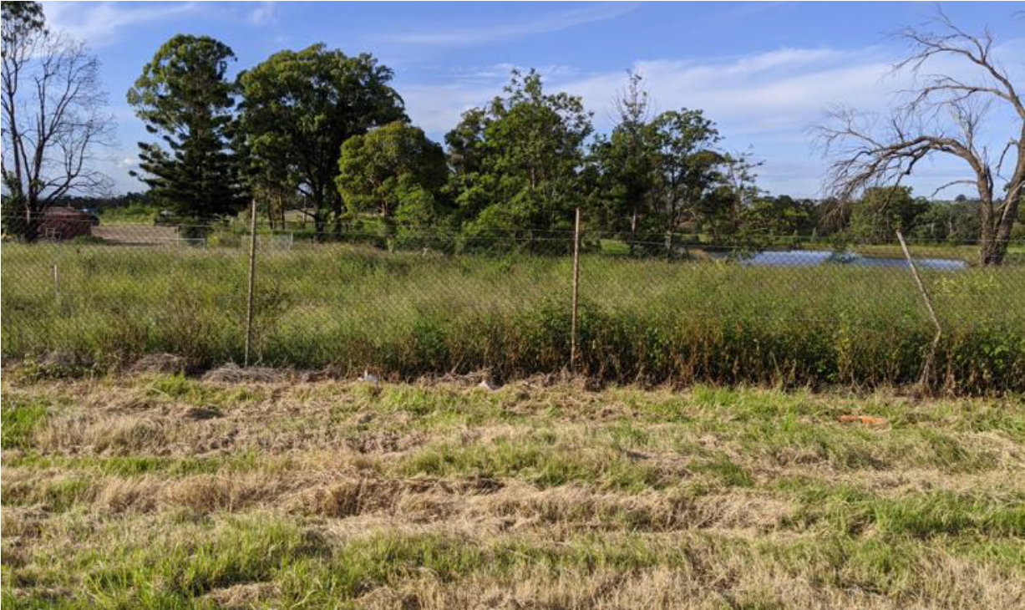
Image 5 – Existing vista on the northern edge opposite the North / South view corridor.

- The panel notes the community concern over traffic, pedestrian safety, height and density.

Council Comment

Traffic

The applicant has submitted a traffic impact assessment which considered vehicle trips generated by the development and the increased volumes to nearby intersections. The assessment revealed that existing intersections on The Hermitage Way in the vicinity of the proposed development will maintain a level of service (LoS) of A and B, with moderate average delays and space capacity, which demonstrates that the proposal will have no detrimental impacts on the operation of the existing road network.

Pedestrian Safety

Additional information was requested of the applicant by Transport for NSW to assess the adequacy of the proposed midblock wombat crossing on Providence Drive via a warrant assessment. Additional information was also requested to determine whether the proposed development would result in heavy vehicle movements entering The Green Way and Providence Drive, potentially impacting the school zone and more vulnerable road users in the vicinity.

The proposed midblock wombat crossing provides an essential piece of infrastructure to facilitate the safe and efficient movement of pedestrians and cyclists between the residential precincts and the proposed Entertainment Precinct to the Gledswood Hills Primary School to the east.

The applicants Traffic Consultant reported that traffic and pedestrian volumes did not meet the numerical warrants outlined in the RMS Guidelines, with the proposed mid-block crossing location able to act as a traffic management device and reinforcing a lower 85th percentile speed along Providence Drive. Formal approval of associated signage and line marking of the proposed mid-block wombat crossing will be subject to the Local Traffic Committee post issue of the development consent.

As the development does not contain an individual floor space tenancy to house an Aldi, Coles or Woolworths, the development does not propose or require larger vehicles (e.g. Heavy rigid) to access The Green Way or the Providence Drive. The proposed grocer development will be able to be serviced by a medium rigid vehicle with access to the loading dock to be managed to occur outside of school peak periods.

As the proposed development does not significantly impact on the operation of existing intersections or is reliant on larger vehicles to service the development, it is considered that the development does not generate any detrimental increase in safety risks to pedestrians or drivers in the locality.

Height

The maximum building height for this site is 18m within the B4 zone. A maximum height of 16m applies to Residential Flat Buildings along the western portion of the site that is zoned R1 – General Residential or 9.5m for all other developments.

The maximum height of buildings within the B4 zoned portion of the site is 18m, with the majority of buildings well below the maximum height of buildings development standard.

As per the Entertainment Village Master Plan, development within the western portion of the site and subject to the lower building height standard will be subject to separate development applications for the development of future precinct B. No building works are proposed within the R1 – General Residential zoned portion of the site apart from an access road from Huntington Street and The Green Way.

Density

The proposed development site is subject to the terms and conditions of the Gledswood Hills Planning Agreement (third deed of variation) executed between Camden Council and SH Camden Valley Pty Limited, dated 12 January 2018, which sets a development yield of approximately 400 dwellings within the Entertainment Precinct. The development proposes 63 residential apartments across three buildings (C9, C10 & C11) adjacent to The Hermitage Way, which is well below the envisaged dwelling yield of the VPA. The proposed development generally complies with the objectives and controls contained in the relevant planning documents and is not considered to be an overdevelopment of the site.

ASSESSMENT

Environmental Planning and Assessment Act, 1979 – Section 4.15(1)

In determining a DA, the consent authority is to take into consideration such of the following matters as are of relevance to the development the subject of the DA:

(a)(i) the provisions of any environmental planning instrument

The environmental planning instruments that apply to the development are:

- State Environmental Planning Policy (State and Regional Development) 2011.
- State Environmental Planning Policy (Sydney Region Growth Centres) 2006.
- State Environmental Planning Policy (Infrastructure) 2007.
- State Environmental Planning Policy (Educational Establishments and Child Care Facilities) 2017
- State Environmental Planning Policy No 55 – Remediation of Land.
- State Environmental Planning Policy No 64 – Advertising and Signage.
- State Environmental Planning Policy No. 65 – Design Quality of Residential Apartment Development.
- State Environmental Planning Policy (Building Sustainability Index: BASIX) 2004.
- Sydney Regional Environmental Plan No 20 – Hawkesbury-Nepean River.

State Environmental Planning Policy (State and Regional Development) 2011 (SRD SEPP)

The SRD SEPP identifies development that is State significant or regionally significant development.

The Panel is the consent authority for this DA as the CIV of the development is $63.8 million. This exceeds the CIV threshold of $30 million for Council to determine the DA pursuant to Schedule 7 of the SRD SEPP.

State Environmental Planning Policy (Sydney Region Growth Centres) 2006 (Growth SEPP)

The Growth SEPP aims to co-ordinate the release of land for residential, employment and other urban development in the North West Growth Centre, the South West Growth Centre and the Wilton Growth Area.

Site Zoning

The site is zoned R1 General Residential and B4 Mixed Use pursuant to Appendix 1, Clause 2.2 of the Growth SEPP.

Land Use Definitions

The development is defined as a “mixed use development” comprising “business premises”, “centre-based child care facility”, “entertainment facility”, “food and drink premises”, “medical centre”, “recreation facility (indoor)”, “shop top housing”, “retail premises”, “shop”, including a “road” by the Growth SEPP.

Permissibility

All of the development is permitted with consent in the zones in which it is proposed pursuant to the land use table in Appendix 1 of the Growth SEPP.

Planning Controls

An assessment table in which the development is considered against the Growth SEPP’s planning controls is provided as an attachment to this report.

State Environmental Planning Policy (Infrastructure) 2007 (ISEPP)

The ISEPP aims to facilitate the effective delivery of infrastructure across the State.

Endeavour Energy (Endeavour)

The DA was referred to Endeavour Energy for comment pursuant to Clause 45 of the ISEPP as the development lot (Lot 289 DP1230815) at lodgement of the application contained electrical easements for overhead power lines and underground cables.

Endeavour Energy raised no objections to the development and recommended compliance with a number of technical guidelines and requirements. A condition requiring compliance with Endeavour Energy’s technical guidelines and requirements is recommended.

Transport for NSW (TfNSW)

The DA was referred to TfNSW for comment pursuant to Clause 104 of the ISEPP as, pursuant to Schedule 3 of the ISEPP, the development is classed as traffic generating development.

Transport for NSW has reviewed the application, including requested additional information, and raised no objection to the development and subject to no specific conditions.

State Environmental Planning Policy (Educational Establishments and Child Care Facilities) 2017.

The educational establishments and child care facilities SEPP aims to facilitate the effective delivery of educational establishments and early education and care facilities across the state. The SEPP requires consideration of any development application for an early education and care facility to meet the applicable criteria of the Child Care Planning Guideline, including satisfying each of the non-discretionary development standards.

A copy of the assessment of the proposed development against the Child Care Planning Guideline and the non-discretionary development standards of the SEPP is provided as an attachment to this report, with assessment of the application revealing that the development is largely consistent with the Child Care Planning Guideline and the non-discretionary development standards of the SEPP.

State Environmental Planning Policy No 55 - Remediation of Land (SEPP 55)

SEPP 55 provides a State-wide planning approach to the remediation of contaminated land.

Clause 7 of SEPP 55 requires the consent authority to consider if the site is contaminated. If the site is contaminated, the consent authority must be satisfied that it is suitable in its contaminated state for the development. If the site requires remediation, the consent authority must be satisfied that it will be remediated before the land is used for the development. Furthermore, the consent authority must consider a preliminary contamination investigation in certain circumstances.

Several development consents have been issued for remediation works across the development site, with a Site Audit Statement issued for the bulk of the Entertainment Precinct development site, with the exception to the former Motel site (AEC8), which was excluded from the initial Development Application for remediation works subject to DA/2013/854/1. Following demolition of the former motel and associated structures, an unexpected find was discovered, consisting of asbestos impacted fill remaining on site behind onsite retaining walls. Following this unexpected find, a Section 96 modification application was granted subject to DA/2016/1180/2 to remediate this asbestos impacted fill material. Remediation and validation have yet to occur of this material.

A further remediation action plan for unexpected finds across the entertainment precinct site was granted consent subject to DA/2019/215/1 to ensure that the site will be rendered suitable for future land use consistent with Residential A in the National Environment Protection (Assessment of Site Contamination) Measure 2013 (No.1)(NEPC, 2013), thereby posing no unacceptable risk to human health or the environment.

Subject to remediation works being completed and validated, the site is considered suitable for future commercial and residential development. An appropriate condition is included in the recommendation to ensure the remediation is completed prior to issue of any construction certificate relating to the subject proposal.

State Environmental Planning Policy No 64 - Advertising and Signage (SEPP 64)

SEPP 64 aims to ensure that signage is compatible with the desired amenity and visual character of the area, provides effective communication in suitable locations and is of high-quality design and finish.

Clause 8 of SEPP 64 requires the consent authority to be satisfied that signage is consistent with the objectives of SEPP 64 and the assessment criteria specified in Schedule 1.

Council staff are satisfied that the signage is consistent with SEPP 64’s objectives in that it is compatible with the desired amenity and visual character of the area, will provide effective communication by displaying the development’s name and will be of a high quality design and finish.

Council staff have also considered SEPP 64’s Schedule 1 assessment criteria and are satisfied that the signage is consistent with it.

State Environmental Planning Policy No. 65 – Design Quality of Residential Apartment Development

SEPP 65 aims to improve the design quality of residential apartment development and provides an assessment framework, the Apartment Design Guide for assessing ‘good design’.

The SEPP requires consideration of any development application for residential accommodation meeting the application criteria of the SEPP against the nine (9) design quality principles, including the advice obtained from a design review panel and the Apartment Design Guide (ADG).

A copy of the assessment of the proposed development against the design criteria and objectives of the ADG is provided as an attachment to this report, with assessment of the application revealing that the development is largely consistent with the ADG and the design quality principles.

The proposed development has been assessed against the SEPP’s design quality principles:

Principle 1: Context and Neighbourhood Character

The surrounding area has undergone a significant transition, as residential subdivision development continues to the north through the conversion of the former El Caballo Blanco Tourist theme park to a residential subdivision development surrounded by a golf course. To the west of the subject site, Huntington Street has recently been registered as public road with attached and detached residential development in the final stages of completion. To the east opposite Providence Drive, the continuous built form of the Gledswood Hills Primary School wraps around the corner of The Hermitage Way. To the south opposite the site, Wests Leagues Country Club exists, with a large at grade car park separating the club from The Hermitage Way.

The proposed development will enhance the walkability of the suburb, which is one of the positive attributes of the area, though its continuous connections of pathways through parks, reserves, riparian areas and along roadways. The development has several wide pedestrian access pathways leading to the village centre, which is an active core of public open space, playgrounds and eateries. The development will likely become a focal point and a destination to arrive at for social interaction.

The Turner Road Precinct DCP envisages that development on this site will provide a variety of recreation, entertainment, residential and support uses, including retail and commercial facilities within the precinct, which the development achieves. This is achieved through variation in the built form and height of buildings to suit the specific land uses desired by the DCP, which are largely consistent with the design outcomes expressed in the DCP.

The proposed development is considered to result in a positive built form for the future character of the area and remaining undeveloped sections of the Entertainment Precinct and will make a positive contribution to the existing context. This has been done by achieving and exceeding compliance with the relevant planning controls that will also guide the development of that future character and context.

Principle 2: Built Form and Scale

All proposed shop top housing buildings maintain compliance with the maximum height of buildings development standard of 18m, proposing 4 storey development fronting The Hermitage Way, but which also overlooks the adjoining village centre to the north. The buildings establish a distinctive lower level of floor to ceiling glazing with an awning above, activating all sides of the building and ensuring that it is relatable to human scale.

The middle section of the building is defined by vertical lines and variation in building materials, predominately consisting of dark brick work, large windows and prominent indentations at the corners of balcony areas. The upper level proposes colourbond pitch roof forms with dormer windows.

The development’s design intent is to create a contemporary reinterpretation of iconic architectural forms from the Camden region, which overlooks a large publicly accessible village square to establish a village feel. The built form is highly activated, providing significant outlook to public domain areas, with good proportions of brickwork and glazing and everlasting masonry materials.

Principle 3: Density

The development has been designed with a high compliance in key ADG amenity criteria, with the bulk of the Entertainment Precinct planned for development prior to the shop top housing apartments being constructed within Stage C (First stage of development) and later subsequent residential stages of the Entertainment Precinct subject to stages A and B under separate applications.

This approach allows the proposed surrounding uses, consisting of the cinema, public playground, aquatic centre and gym, specialty retail premises and a range of food and beverage options to be operational first, therefore establishing facilities and recreational options ahead of the arrival of residents and creating a sense of place.

The development has been designed to create a village character, with a large central accessible space that is vibrant and playful. The central open space is highly activated via glazed shopfronts fronting the village centre, and through multiple pedestrian pathways leading to Gledswood Hills Primary School and to the Gledswood Hills Country Club. The central village square is linked to other wide public domain areas within the proposed development, allowing for external dining areas and opportunities for social interaction.

Principle 4: Sustainability

The proposed development will incorporate a number of sustainability features including solar access and natural ventilation consistent with the ADG objectives, and compliance with BASIX requirements. Photovoltaic cells are proposed on the roof tops of buildings C9, C10 and C11 to achieve a minimum rated electrical output of 5.0 peak kW.

The entire Entertainment Precinct is walkable, with each public open space area connected to each other via wide pedestrian corridors. Bicycle storage also exists within the development to promote alternative and sustainable transport options to and from and beyond the site.

Principle 5: Landscape

In lieu of providing a designated area of communal open space, the development proposes a large publicly accessible area, which contains areas of landscaping, seating, shading and a combination of soft and paved surfaces, providing recreation and social interaction opportunities. The development, and particularly the open space area, are extensively planted with large trees throughout.

Principle 6: Amenity

The proposed apartments’ layouts and designs are compliant with the ADG design criteria and will provide a high level of amenity for future residents, with immediate and walkable access to various social and recreational opportunities, including a child care centre within the Entertainment Precinct, with outlook over the village centre area and district vistas to the north over the neighbouring golf course.

Principle 7: Safety

The proposed village centre and accompanying areas of publicly accessible open space are activated and vibrant with varying uses to produce an environment that is safe and secure. Clear and designated pedestrian routes provide legible and defined pathways through the development.

The proposed buildings provide active frontages to The Hermitage Way, including towards the central village centre and other public open space areas, maximising passive surveillance opportunities. Controlled access will be provided to the proposed buildings via secured lobbies and lifts. Secure resident parking areas will be provided in the proposed basement.

Principle 8: Housing Diversity and Social Interaction

The proposed development will provide a variety of apartment types and sizes, including adaptable units and 20% of units meeting the Liveable Housing Guidelines silver level universal design features.

The development has been designed to create a village character, with a large central accessible space that is vibrant and playful. The central open space is highly activated via glazed shopfronts fronting the village centre, and through multiple pedestrian pathways leading to Gledswood Hills Primary School and to the Gledswood Hills Country Club. The central village square is linked to other wide public domain areas within the proposed development, allowing for external dining areas and opportunities for social interaction.

Principle 9: Aesthetics

The development’s design intent is to create a contemporary reinterpretation of iconic architectural forms from the Camden region, which overlooks a large publicly accessible village square to establish a village feel. The built form is highly activated, providing significant outlook to public domain areas, with good proportions of brickwork and glazing and everlasting masonry materials.

The proposed layout and urban form respond’s positively to establishing an active and vibrant entertainment precinct envisaged by the DCP, which seeks the provision of a variety of recreational, entertainment, residential and support uses, including retail and commercial facilities within the precinct.

State Environmental Planning Policy (Building Sustainability Index: BASIX) 2004

The applicant has submitted valid BASIX certificates in support of the DA that demonstrate that water, thermal comfort and energy requirements have been achieved.

Sydney Regional Environmental Plan No 20 - Hawkesbury-Nepean River (SREP 20)

SREP 20 aims to protect the environment of the Hawkesbury-Nepean River system by ensuring that the impacts of future land uses are considered in a regional context.

The development is consistent with the aim of SREP 20 and all of its planning controls. There will be no detrimental impacts on the Hawkesbury-Nepean River system as a result of the development. Appropriate erosion, sediment and water pollution control measures have been proposed as part of the development.

(a)(ii) the provisions of any proposed instrument that is or has been the subject of public consultation under this Act and that has been notified to the consent authority (unless the Secretary has notified the consent authority that the making of the proposed instrument has been deferred indefinitely or has not been approved)

Draft Environment State Environmental Planning Policy (Draft Environment SEPP)

The development is consistent with the Draft Environment SEPP in that there will be no detrimental impacts on the Hawkesbury-Nepean River system as a result of it.

(a)(iii) the provisions of any development control plan

The development control plans that apply to the development are:

- Camden Development Control Plan 2019 (requirements for notification and car parking rates); and
- Turner Road Precinct Development Control Plan 2019

Turner Road Precinct Development Control Plan 2019 (Turner Road DCP)

Planning Controls

An assessment table in which the development is considered against the Turner Road Precinct DCP is provided as an attachment to this report. Proposed variations are outlined below:

Road Design / Realignment

The applicant proposes a variation to Part B Clause 3.3 of the DCP seeking an alternative road location to the desired east / west road (proposed as The Greenway). As per the layout plan, the desired east / west road through the Entertainment Precinct is envisaged to be located adjacent to the northern property boundary adjoining golf course land. The proposed development seeks to re-align the east – west road by setting the road approximately 20 metres further to the south.

The proposed re-alignment of this local road further to the south does not impede the local traffic network or the ability of this road to cater for through traffic, as the road does not extend or continue further east or west and is purely for local traffic entering the Entertainment Precinct.

It is considered that the alternate road location is superior to that envisaged in the layout plan as it will allow the built form of the Entertainment Precinct to be further broken up and developed either side of the east / west road (The Greenway). It will also allow an opportunity for a better interface with the adjoining northern RE2 Private Recreation zoned land and the ability for future development to obtain district views over and through the golf course.

The proposed road location remains consistent with the objectives for access and movement through the Entertainment Precinct as per the DCP and will result in a better planned outcome for the precinct in lieu of providing a road on the periphery of the entertainment precinct.

Road Design

The applicant proposes a variation to Clause 3.1 of the DCP, seeking to vary the width of the east / west local road (The Greenway), by increasing the entire width from 14.4m to 15.7m; amending the road verge width to between 2m and 3.1m in lieu of 3.5m on the southern verge; and amending the road carriageway width to between 6m and 7m in lieu of 7.4m. The proposed road also seeks to dedicate a designated parking bay on both sides of the road within the western section of the road and alongside the northern side of the road on the eastern section. The creation of dedicated parking outside of the central road carriageway within a local road is contrary to DCP requirements, which allow parking of vehicles within the carriageway.

The applicant has provided the following reasons in support of the proposed variation:

“The Hermitage Way and Providence Drive are the primary routes for traffic and access to the new Gledswood Village Centre. The Greenway is a local street only within the new masterplan street hierarchy. Its primary role is to provide access to some of the future residential buildings within Precincts A and B, and add to the permeability and wayfinding within the overall development. The northern side of the Greenway is designed as per the DCP road reserve requirements which is appropriate for its interface with the adjacent residential buildings. The southern side is deliberately reconfigured to be site specific and reflect the civic interface with the non-residential uses to that side of the street. The wider pavement in this location allows for ease of use for those parking along that side of the street and accessing the aquatic centre, childcare, and dining precinct. The extent of hard landscaping and reduced planted zone allows for logical desire lines and aid users such as parents with prams, etc.”

Council supports the applicant’s justification for an alternative form of local road, noting that this road bisects the Entertainment Precinct, with alternative interfaces to the southern (non-residential uses) and northern (future residential) sides of the road. It is agreed that each public domain interface requires a different treatment within the road verge as a result of the different uses and built form occurring on opposite sides of the road.

Whilst variation is proposed to increase the total width of the road, this allows for dedicated car parking to be made alongside the road outside of the carriageway and increased on-street supply of car parking. Whilst the road carriageway width is slightly less than DCP requirements, the road width is still adequate to enable vehicles to travel through, noting that DCP requirements allow parking to occur within the road carriageway. The proposed road design reinforces the primary function of the road, which is to provide an accessway through the Entertainment Precinct, but also as a pedestrian permeable means to walk and travel along with wider footpaths for pram access.

The ability of the road to convey traffic through the Entertainment Precinct is not compromised despite the variations sought, with on-street parking, indented street pits and a pedestrian crossing, creating traffic calming devices to establish a slow speed road environment.

View Corridor

The applicant proposes a variation to Clause 2.2(1) of Part B1 – The Entertainment Precinct regarding the principle north – south view corridor width through the middle of the site.

The development application proposes variation to Turner Road Precinct Development Control Plan 2019, seeking to vary the width of the principle view corridor (north / south) through the middle of the site from 20m to 14m/15m in part, which represents a variation of 30% (6m reduction). Adjacent to The Hermitage Way, the view corridor width is 30.66 metres and compliant between the shop top housing buildings C10 and C11. Narrowing of the view corridor commences between the lower height buildings C3, C4 and C5 on the central and northern sections of the site.

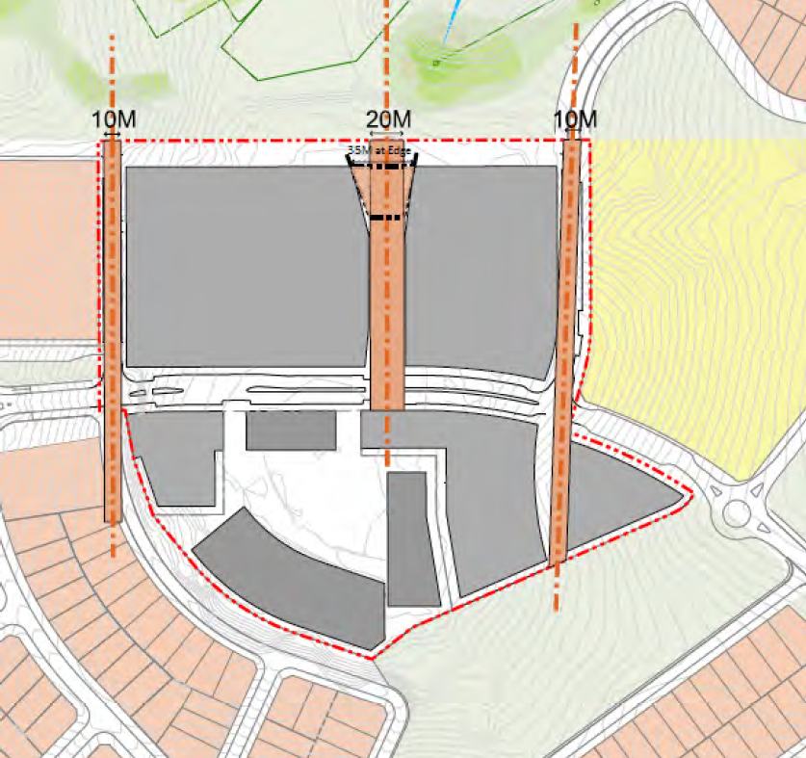
Image 6 – Primary and secondary view axis Figure 2 of Turner Road Precinct DCP 2019

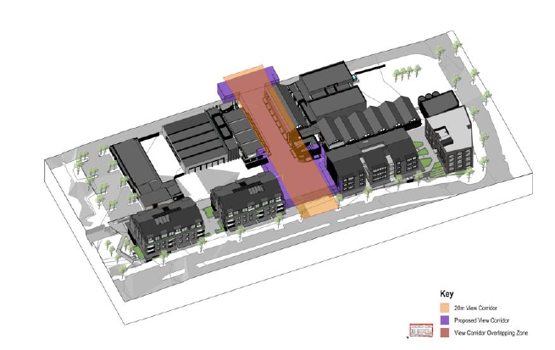
Image 7 – Proposed view corridor

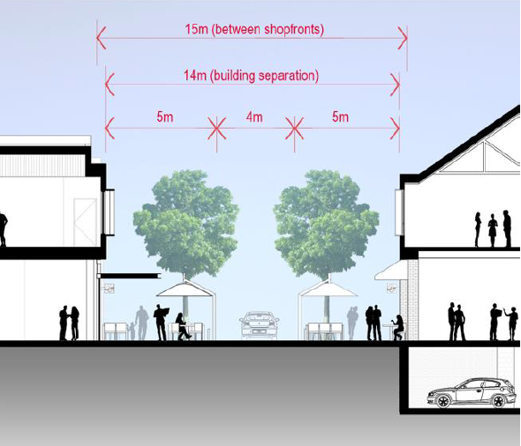
Image 8 – Proposed view corridor in section

The applicant has provided the following reasons in support of the proposed variation:

“To create a vibrant and atmospheric space that reflects a village ‘type’ character through the site, the proximity of retail and scale of a space is highly important. The height of buildings proposed (1-2 storeys) will not contain the space to support a 20m wide corridor. The proposed reduced width of 14m between buildings with indented shop fronts 15m apart will result in a more successful vibrant village corridor.

The reduction (in width) of this north south axis has a minimal impact to the view cone through the site due to the existing site topography and angled nature of the view corridor with regard to the overall masterplan.

……the existing view is not a significant vista and predominately contains a cluster of mature trees and temporary detention basin. Therefore, the proposed reduced corridor width of 14m is considered appropriate and remains consistent with the vision and objectives for the Entertainment Precinct.”

It is considered that the reduction in the width of the view corridor is appropriate in this instance as the lower height buildings (1-2 storeys) framing the north / south view corridor will not contain the space to support a 20m wide corridor to create a vibrant village corridor space. Buildings C3, C4 and C5 are proposed food and drink premises to create a dining avenue. In addition, the existing vista to the north as represented within image 5 (shown earlier within this report), demonstrates that the existing view is not a significant vista and consists of a cluster of trees and a temporary detention basin with little opportunity for direct views to the heritage homestead.

Consequently, it is recommended that the Panel support these proposed variations to the Turner Road Precinct DCP.

(a)(iiia) the provisions of any planning agreement that has been entered into under section 7.4, or any draft planning agreement that a developer has offered to enter into under section 7.4

The proposed development site is subject to the terms and conditions of the Gledswood Hills Planning Agreement (third deed of variation) executed between Camden Council and SH Camden Valley Pty Limited, dated 12 January 2018. The terms of the voluntary agreement require the developer to provide a monetary development contribution. Based on lots within Stage E of the VPA, a monetary contribution figure has been calculated and is included within the recommended conditions. No other development contributions apply to Stage E.

The VPA also establishes a maximum development yield of approximately 400 dwellings within the Entertainment Precinct. As the proposed development only seeks to construct 63 residential apartments, the development is well within the development yield envisaged by the VPA.

(a)(iv) the regulations (to the extent that they prescribe matters for the purposes of this paragraph)

The Environmental Planning and Assessment Regulation 2000 prescribes several matters that are addressed in the conditions attached to this report.

(b) the likely impacts of the development, including environmental impacts on both the natural and built environments, and social and economic impacts in the locality

As demonstrated by the assessment, the development is unlikely to have any unreasonable adverse impacts on either the natural or built environments, or the social and economic conditions in the locality.

(c) the suitability of the site for the development

As demonstrated by the above assessment, the site is considered to be suitable for the development.

(d) any submissions made in accordance with this Act or the regulations

The DA was publicly exhibited for a period of 27 days in accordance with Camden Development Control Plan 2019. The exhibition period was from 29 April to 26 May 2020 and seven submissions were received.

The following discussion addresses the issues raised in the submissions.

- Increased traffic and danger to pedestrians and school children.

Officer Comment

The applicant has submitted a traffic impact assessment which considered vehicle trips generated by the development and the increased volumes to nearby intersections. The assessment revealed that existing intersections on The Hermitage Way in the vicinity of the proposed development will maintain a level of service (LoS) of A and B, with moderate average delays and space capacity, which demonstrates that the proposal will have no detrimental impacts on the operation of the existing road network.

With respect to pedestrian safety, additional information was requested of the applicant by Transport for NSW to assess the adequacy of the proposed midblock wombat crossing on Providence Drive via a warrant assessment. Additional information was also requested to determine whether the proposed development would result in heavy vehicle movements entering The Green Way and Providence Drive, potentially impacting the school zone and more vulnerable road users in the vicinity.

The proposed midblock wombat crossing provides an essential piece of infrastructure to facilitate the safe and efficient movement of pedestrians and cyclists between the residential precincts and the proposed Entertainment Precinct to the Gledswood Hills Primary School to the east.

The applicants Traffic Consultant reported that traffic and pedestrian volumes did not meet the numerical warrants outlined in the RMS Guidelines, with the proposed mid-block crossing location able to act as a traffic management device and reinforcing a lower 85th percentile speed along Providence Drive. Formal approval of associated signage and line marking of the proposed mid-block wombat crossing will be subject to the Local Traffic Committee post issue of the development consent.

As the development does not contain an individual floor space tenancy to house an Aldi, Coles or Woolworths, the development does not propose or require larger vehicles (e.g. Heavy rigid) to access The Green Way or the Providence Drive. The proposed grocer development will be able to be serviced by a medium rigid vehicle with access to the loading dock to be managed to occur outside of school peak periods.

Adequate sightlines from new proposed driveways and new roads are achieved, with access and parking configurations considered to not generate any increase in safety risks to pedestrians or drivers.

As the proposed development does not significantly impact on the operation of existing intersections or is reliant on larger vehicles to service the development, it is considered that the development does not generate any detrimental increase in safety risks to pedestrians or drivers in the locality.

- Height of development and visual impact on the streetscape.

Officer Comment

The proposed development is compliant in respect to the maximum height of buildings development standard prescribed under State Environmental Planning Policy (Sydney Region Growth Centres) 2006 (Growth SEPP).

It is considered that the development is not visually obtrusive and provides buildings that are separated; vary in height and building form (including roof form); anchor corners (where proposed on corners) are visually interesting; activate the public domain through extensive glazing; and provide a good variety of quality materials and everlasting finishes, which consist of masonry brickwork, metal and fibre cement cladding, vertical battens and colorbond.

The proposed materials and finishes are considered to be inclusive elements of the Camden Local Government Area and surrounding areas and will enhance the design features of the proposed development, which is considered to have high architectural merit and will generate visual interest.

- Aesthetics of the area

Officer Comment

The northern part of Gledswood Hills is an emerging residential suburb with surrounding areas to the north and north east also transitioning to new residential subdivisions. The streetscape along The Hermitage Way has an urban character but is not strictly residential noting the existence of Wests Leagues Country Club and Gledswood Hills Primary School opposite the development site to the south and east.
The proposed development is not considered visually offensive or unsympathetic in respect to its design to this section of The Hermitage Way, noting compliance with the maximum building height development standard, setbacks and built form controls of the DCP.

- Parking.

Officer Comment

The proposed development satisfies the car parking requirements for the development in accordance with the car parking rates as per the Camden DCP and the Turner Road Precinct DCP.
- Attraction of unwanted people to the area, crime and security.

Officer Comment

Concern has been raised that the development will attract unwanted people to the area, increase crime and compromise the security of the area.

The Entertainment Precinct is envisaged by the DCP and will become a sought-after destination and focal point for social interaction and recreation via the cinema, large children’s playground and eateries within the precinct.

The development has been designed to create a village character, with a large central accessible space that is vibrant and playful. The central open space is highly activated via glazed shopfronts fronting the village centre, and through multiple pedestrian pathways leading to Gledswood Hills Primary School and to the Gledswood Hills Country Club. The central village square is linked to other wide public domain areas within the proposed development, allowing for external dining areas and opportunities for positive social interaction.

A safer by design evaluation of the proposal has been made by NSW Police who conclude that the crime risk from the proposal is low.

- No need for additional units/apartments, proposed businesses and medical centres and childcare facilities within Gledswood Hills.

Officer Comment

The proposed development is the first stage of developing the Entertainment Precinct at this location and will deliver “business premises”, “centre-based child care facility”, “entertainment facility”, “food and drink premises”, “medical centre”, “recreation facility (indoor)”, “shop top housing”, “retail premises” and a “shop”, which are all envisaged by the Turner Road Precinct DCP, which identifies this site as being suitable for the Entertainment Precinct.

The proposed uses are all permissible with consent within the B4 Business Zone.

The proposed development will provide a stimulus to the local economy through the generation of employment during construction, as well as to future part time and full-time employment of the proposed businesses. Accordingly, the proposed development is considered to have positive benefits to Gledswood Hills.

In respect to child care centres, subject to Clause 25(2)(a) of State Environmental Planning Policy (Educational Establishments and Child Care Facilities) 2017, a child care centre development may be located at any distance from an existing or proposed early education and care facility.

- Garbage/Litter

Officer Comment

Submissions received raise concern that the development will result in garbage littering adjoining streets. Generally, excess waste and litter generation results from poor human behaviour and the inadequacy of disposal areas to remove waste. The development per se is unlikely to result in significant waste generation, with assessment of waste generation revealing that the development will have acceptable waste and recycling areas for residential and commercial areas of the development. In addition, waste bins are proposed to be provided within the central open space area for the disposal of waste to minimise litter leaving the site.

- Undesirable precedent for future development

Officer Comment

Submissions received raise concern that approval of this development will set an undesirable precedent for future development. The proposed development is envisaged by the Turner Road Precinct DCP, which identifies this site on the Indicative Layout Plan for the purpose of The Entertainment Precinct. The DCP lists several vision and development objectives for the Entertainment Precinct, which include “To support the provision of a variety of recreation, entertainment, residential and support uses within the precinct” and “To create a mixed use entertainment, leisure, support retail and amenity services and residential precinct focused around and adjacent to the Entertainment Precinct”.

The initial stage of the development is proposed to deliver the core public and commercial functions of the precinct and provides the base facilities (such as parking, loading and commercial waste) to establish the precinct. As detailed within this assessment, the development is highly compliant with the numerous planning controls, particularly, height, setbacks, built form, carparking and amenity (solar access and natural ventilation), which dictate built form.

The proposed development satisfies key planning controls and matters for consideration and proposes a development that is highly functional and legible, accessible and connected to adjoining development through the connectivity of pedestrian pathways, visually interesting and of high architectural merit and will likely become a focal point and a destination to arrive at for social interaction.

The proposed development is considered to result in a positive built form for the future character of the area and remaining undeveloped sections of the Entertainment Precinct and will make a positive contribution to the existing context for future development to follow.

- Poor quality build.

Officer Comment

An objection has been received concerned that the application may be on-sold and developed by another developer and not built to the same quality and standards as per the proposed development. The consent authority cannot control whether the land is sold or otherwise. Regardless if the land and DA consent is on-sold, the development will still be required to be developed in accordance with the consent, which requires satisfying the BCA, several Australian Standards, Council’s Engineering Specifications and constructed of the materials and finishes specified in the application.

- Devalue property prices

Officer Comment

No evidence has been provided to support this claim and regardless this is not a valid matter for consideration under Section 4.15 of the Environmental Planning and Assessment Act.

(e) the public interest

The public interest is served through the detailed assessment of this DA under the Environmental Planning and Assessment Act, 1979, the Environmental Planning and Assessment Regulation 2000, environmental planning instruments, development control plans and policies. Based on the above assessment, the development is consistent with the public interest.

EXTERNAL REFERRALS

The external referrals undertaken for this DA are summarised in the following table:

External Referral | Response
Transport for NSW. | No objection. No specific conditions recommended.
Endeavour Energy. | No objection and conditions recommended.
Camden Police Area Command. | No objection and safer by design recommendations provided.

Conditions from external referral recommendations will be imposed.

FINANCIAL IMPLICATIONS

This matter has no direct financial implications for Council.

CONCLUSION

The DA has been assessed in accordance with Section 4.15(1) of the Environmental Planning and Assessment Act, 1979 and all relevant instruments, plans and policies. The DA is recommended for approval subject to the conditions attached to this report.

RECOMMENDED
That the Panel approve DA/2020/202/1 for a mixed-use development at 1-9 Providence Drive, Gledswood Hills subject to the conditions attached to this report.

